ISLAMIC UNIVERSITY OF TECHNOLOGY
Organization of Islamic Cooperation
Board Bazar, Gazipur

Performance Analysis
of Job-Shop Model
CSE 4550
Muhammad Mahbub Alam
Imtiaj Ahmed Chowdhury

Description
In this report, we present a comparison of the results of the output statistics derived from our Job-Shop Model simulations. The output statistics that were considered are:
- Average waiting delay, i.e. Queuing Delay
- Average number of jobs in the system, i.e. System Size
- Average server utilization
These values were calculated based on randomly generated arrival and departure times for 100 customers. The mean arrival time was assumed to be exponentially distributed at 10 time-units. The mean departure time (for the system) was assumed to be exponentially distributed and was varied between 4.75 to 9.25 time-units. For simplicity, the mean departure time for all servers have been considered to be equal.
There was a total of 5 workstations, each of which had a single queue and 3, 2, 4, 2 and 1 server respectively.

The order in which customers navigated the system was uniformly and randomly distributed as follows:
- Workstations 3, 1, 2 and finally 5, with a probability of 0.3.
- Workstations 4, 1 and finally 3, with a probability of 0.5.
- Workstations 2, 5, 1, 4 and finally 3, with a probability of 0.2.

Simulation Results

Collected Data
Arrival Mean | Departure Mean | Traffic Intensity | Average Queueing Delay | Average System Size | Average Server Utilization
10 | 4.75 | 0.475 | 10.0384 | 0.159986 | 0.142133
10 | 5 | 0.5 | 7.97402 | 0.159094 | 0.145273
10 | 5.25 | 0.525 | 6.22163 | 0.140305 | 0.129542
10 | 5.5 | 0.55 | 8.48025 | 0.173055 | 0.155331
10 | 5.75 | 0.575 | 45.7998 | 0.26596 | 0.192602
10 | 6 | 0.6 | 26.5527 | 0.23873 | 0.189504
10 | 6.25 | 0.625 | 19.6217 | 0.270292 | 0.226241
10 | 6.5 | 0.65 | 44.3474 | 0.24811 | 0.187148
10 | 6.75 | 0.675 | 27.8192 | 0.256047 | 0.21463
10 | 7.25 | 0.725 | 30.882 | 0.267193 | 0.198082
10 | 7.5 | 0.75 | 72.0206 | 0.329865 | 0.219407
10 | 8 | 0.8 | 36.3875 | 0.289463 | 0.227572
10 | 8.25 | 0.825 | 102.535 | 0.395864 | 0.244896
10 | 8.5 | 0.85 | 83.9238 | 0.412491 | 0.275741
10 | 8.75 | 0.875 | 60.3558 | 0.421864 | 0.307004
10 | 9 | 0.9 | 41.6473 | 0.327609 | 0.251815
10 | 9.25 | 0.925 | 171.521 | 0.464903 | 0.262443

Average Queuing Delay
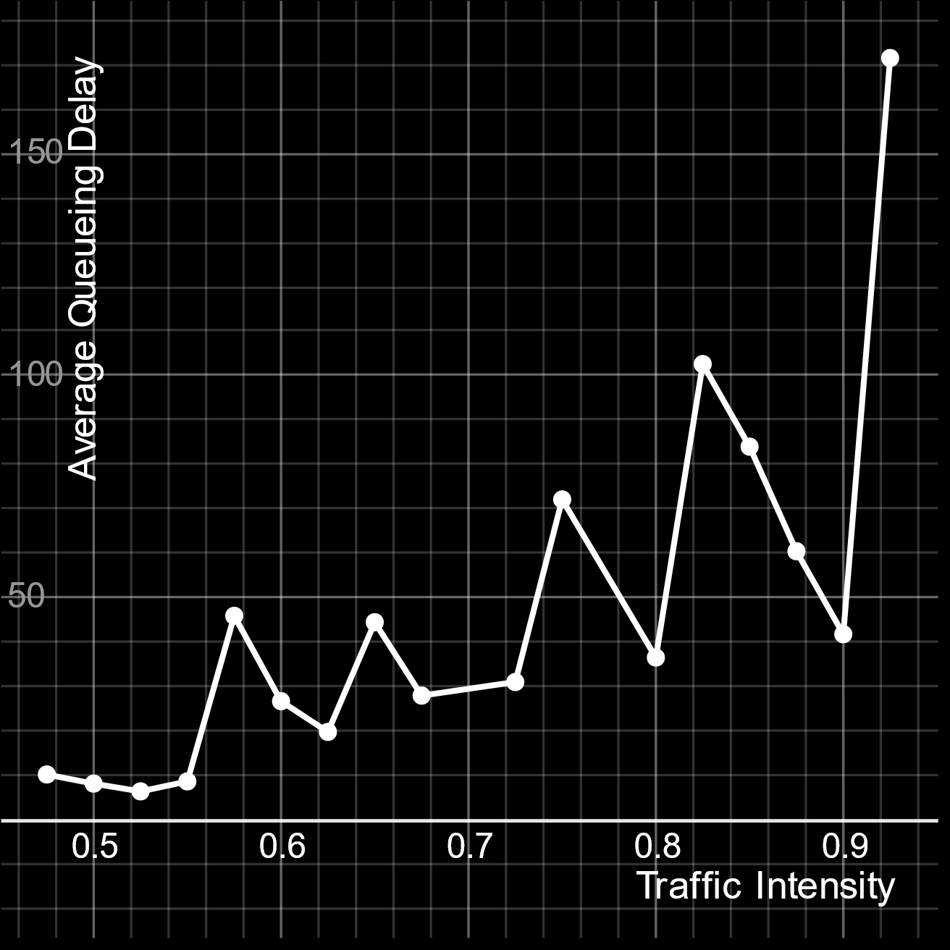
The average queueing delay seems to increase as traffic intensity increases. This makes sense, since the lower the difference between how often customers arrive and how often they depart, the more likely it is that a customer will have to wait in the queue for longer.

Average System Size
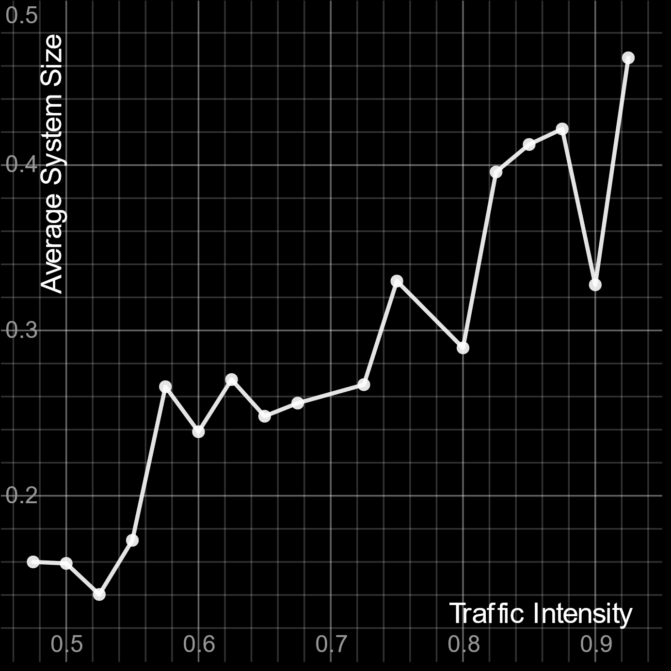
The system size tends to go up as traffic intensity increases. This is in line with the definition of traffic intensity, which is the average occupancy of a system.

Average Server Utilization
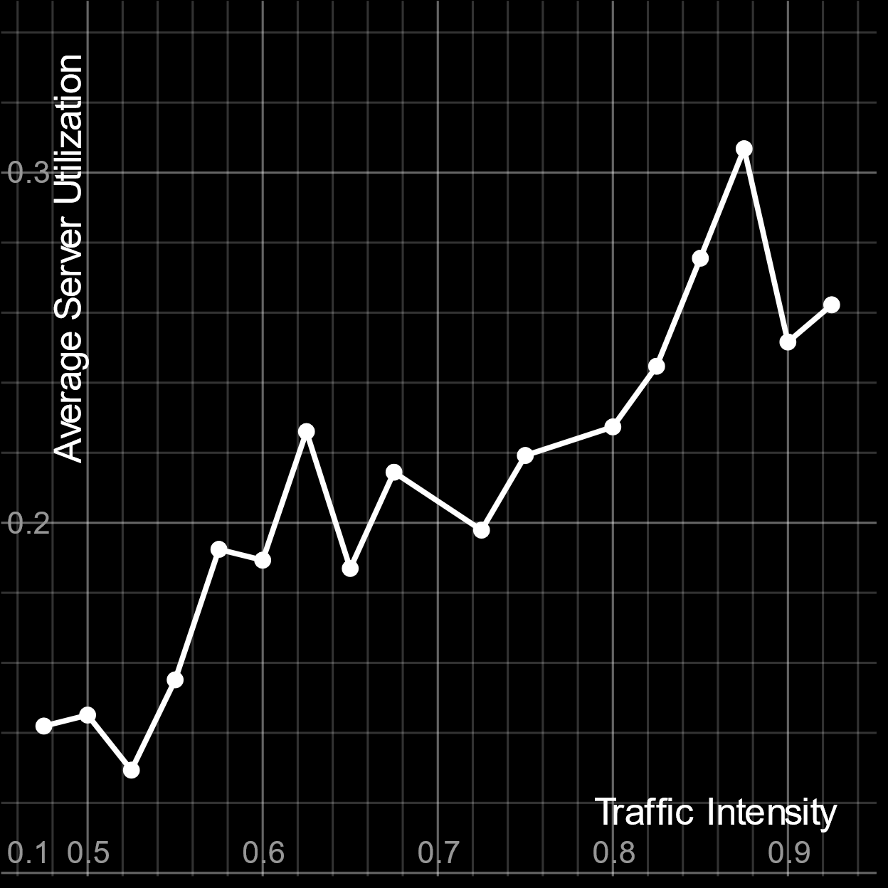
The average server utilization tends to increase as traffic intensity increase. If there are a higher number of customers in the system, it becomes less likely that a particular server will remain idle.

